National 5 Practical Cookery question paper setting grid 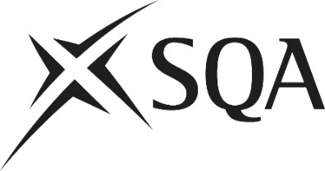

Skills being tested | Marks | 1(a) | 1(b) | 1(c) | 1(d) | 1(e) | 2(a) | 2(b) | 2(c) | 2(d) | 2(e) | 3(a) | 3(b) | 3(c) | 3(d) | 3(e) | Total marks
Equipment, weigh and measure | 3 marks (+/- 3)
Cookery processes, food prep techniques
Characteristics* | 18 marks
CDA* | (+/- 3)
Safe and hygienic storage
Sustainability
Costing* | 9 marks
Presentation, taste and texture* | (+/- 3)
Command words
Name, state, give, identify | 7–12 marks
Describe
Explain | 9–14 marks
Calculate | 6–12 marks
Evaluate | 6–12 marks
Grade targeted A | Max 30% (9 marks)
Grade targeted C | Max 50% (15 marks)

