



National Qualifications: General Marking Instructions 2026

02 March 2026
Version 1

© Qualifications Scotland [YEAR]

We are committed to using plain language. If you have any suggestions on how we can improve, let us know at editor@qualifications.gov.scot.

Contents
Qualifications Scotland key contacts list 1
General marking instructions (for all markers) 2
How to read these instructions 2
Key performance measures for markers 2
Feedback on marking in previous years 3
On receipt of script packets 3
Marking scripts 3
Marking arrangements 4
Principal Assessor (PA) referrals 5
Coursework exceptions 6
Entries on mark sheets (Attendance Register) 6
Assessment arrangements 7
Child and adult protection concerns 7
Suspected malpractice 7
Unsigned coursework flyleafs 8
Marker report 8
Additional information for traditional marking 9
Delivery of scripts 9
Checking of packets on delivery 9
Marking scripts 10
Marking arrangements 10
Record of Marks and Despatch to Qualifications Scotland Form 10
Marker report 11
Return of marked and unmarked scripts 11
Additional information for central marking 12
Marker report 12
Appendices 13
Appendix 1: Attendance Register (mark sheet) 13
Appendix 2: Referral form 14
Appendix 3: Record of Marks and Despatch 15
Appendix 4: Marker’s checklist 16
Appendix 5: Return of examinations materials label 17

Qualifications Scotland key contacts list
In any communication with Qualifications Scotland, please quote your marker code number.
Issue | Who to contact
Enquiries about your appointment: | Marker Helpline: 0345 213 6825  (08:30–16:30 Mon to Thu,  08:30–15:30 Fri,  10:00–12:00 Sat to Sun)  email: markers@Qualifications.gov.scot
Enquiries or discrepancies with receipt of scripts and marker pack material, difficulties with the completion or return of scripts: | External Assessment Helpdesk: 0345 213 6612 (option 4)  (08:00–21:00 Mon to Fri,  09:00–17:00 Sat to Sun and public holidays)  email: external.assessment@Qualifications.gov.scot
Enquiries about transcriptions: | Assessment Arrangements Team: 0345 213 6890  (08:30–16:30 Mon to Thu,  08:30–15:30 Fri)  email: aarequests@Qualifications.gov.scot
If you have concerns about the welfare of a candidate: | Child and Adult Protection: 0345 213 6587  (08:30–16:30 Mon to Thu,  08:30–15:30 Fri)  email: welfare@Qualifications.gov.scot

General marking instructions (for all markers)

How to read these instructions
These instructions are for markers who will mark scripts on paper at home (traditional marking) and those who will mark scripts at a Qualification Scotland event (central marking). This general section applies to both types of marking, and there are two separate sections of additional information — one for each type.
The term ‘mark’ (when used as a noun) should be understood to encompass course-specific preferred terms such as point, score, or grade. The word ‘script’ should be taken throughout as referring to work produced by a single candidate. This work will sometimes comprise the candidate’s response to two papers.
Please read the following instructions carefully. They relate to general procedures not described in the subject or paper-specific marking instructions. See Appendix 4 for a checklist to help you make sure that all appropriate actions have been taken.

Key performance measures for markers
Each year, when you have completed the duties outlined in your marker contract, we will measure your performance against the following key performance measures (KPMs) and tell you the outcome.
- Mark agreed allocation in line with detailed marking instructions.
- Submit marks, return marked materials (where appropriate) and complete administrative tasks by specified dates and in accordance with Qualifications Scotland policy and instructions.
- Submit a detailed marker report on completion of marking allocation, providing feedback on examination performance.
- Demonstrate behaviours outlined in the Terms and Conditions of Appointment which support Qualifications Scotland’s values. This is available within the contract area of Appointee Portal.

Feedback on marking in previous years
During previous post-examination procedures, errors were found in the addition and transcription of marks. Although no formal part of the post-examination procedures is dedicated to checking markers’ addition, errors may be identified during other procedures, such as marker check. You must pay due care and attention to these administrative tasks, as even a small error could make a grade’s difference to a candidate.
You must provide a marker report on your marking experience — this information is vital to post-examination procedures. We will conduct quality checks and, where we find addition or transcription errors, or we receive no marker report, we will adjust marker grades accordingly. This may impact on future marking appointments.

On receipt of script packets
Open each packet carefully, where the sealing label has been placed, and then:
1 Check the number of candidates noted on the outside of the packet against the number of candidates whose scripts are enclosed. If there is a discrepancy, change the number on the outside of the packet in red ink to agree with the number of candidates whose scripts are enclosed. There is no need to identify the packet for special attention — return it in the normal way with your marked scripts.
2 Check the details on the Attendance Register Form against those on the packet label (see Appendix 1).
3 Check that the candidates whose scripts are enclosed are those whose personal details (name, Scottish Candidate Number, date of birth) are listed on the Attendance Register.
4 Check that the scripts received are appropriate to the paper you have been appointed to mark.

Marking scripts
You should record all the marks you have awarded for each question or section of the candidate’s response on the marks grid (usually on the back outside cover of the script) and note the total mark on the front of the candidate’s script. It is vital that each mark is clear and unambiguous and is exactly as indicated in the finalised marking instructions for the subject and level in question.

Marking arrangements
1 In your marking, make your intentions clear (using codes where these have been agreed) for the benefit of our staff and any others who may refer to the script later. Do not write any comments on candidates’ scripts.
2 Mark and value every question that the candidate has answered and enter the mark you have awarded in red ink on the script, in line with the finalised marking instructions. Occasionally, candidates skip one or two pages in the script by mistake and proceed to answer questions further on in the script. You should ensure that all answers have been marked.
3 Candidates are advised to cross out any rough work when they have made a final copy. However, you must mark crossed-out work if the candidate has not made a second attempt to answer the question. Where a second attempt has been made, you should ignore the crossed-out answer.
4 Record marks clearly in the columns provided in the script. Complete the grid on the outside cover of the script to indicate the marks awarded for each question. Add these marks together and enter the total mark for the paper in the ‘total’ box on the top right of the front cover of the script (The total mark must be given as a whole number, where necessary by rounding up).
5 Check all your additions carefully, by summing marks from the first to the last page of the script, and then from the last to the first page. You should also check the transcription of marks, both within scripts and to the mark sheets (refer to the section ‘Entries on mark sheets’).
6 Where a candidate has used an additional sheet (for example an answer booklet or square-ruled paper), indicate clearly that all the work on the additional sheet has been considered, without adding further comments. All marks (including any awarded on additional sheets) must be indicated on the candidate's answer booklet.
7 If options are given in the paper, ensure that the candidate does not receive credit for answering more than the prescribed number of questions. If the candidate has exceeded the prescribed number, mark the answers, and select the highest marks (consistent with the rubrics of the paper) for inclusion in the total. Cross through the answers that are not included in the total.
Draw attention to the fact that the candidate has exceeded the prescribed number of questions by noting ‘Rubric’ on the front of the script, not on the mark sheet on the Attendance Register Form.
8 Please ensure that the total mark has been transcribed accurately to the mark sheet on the Attendance Register Form, and that the Attendance Register Form and the scripts are returned to their original packet.
9 When you return the scripts to the packet, please ensure that the order agrees with the order on the Attendance Register Form. Where there is more than one booklet for a candidate, please ensure that they are placed one inside the other.
You should mark a candidate’s script as a whole entity — do not mark your allocation of scripts on a question-by-question basis.

Principal Assessor (PA) referrals
Where issues arise during the marking process and you have serious doubt or difficulty in assigning a mark to a piece of work, mark the script and refer it to the PA. You should write ‘PA Referral’ clearly on the front of the script under the ‘For Official Use’ grid and complete a referral form (see Appendix 2), ticking the principal assessor referral box on the form. There are copies of this form in your marker pack.
You should insert these forms inside the front cover of the script or, in the case of coursework, place them in front of the script, inside the clear-faced bag. Write ‘PA’ alongside the candidate’s name on the mark sheet on the Attendance Register Form and enter your provisional marks in the appropriate mark columns. Always note a provisional mark on the script and Attendance Register Form mark sheet, even if this is a mark of zero.
On the front of the packet containing the referred script, write ‘Special Attention (PA)’.
- For traditional marking, the packet is then returned to Qualifications Scotland in the normal way.
- For central marking, the packet is passed to the PA at the marking event.
For marking issues which the PA cannot resolve, please see section ‘Entries on mark sheets’, point 9.
You must not use the referral form to make general observations on candidate or centre performance — make these in your marker report.
Where candidates have used an assessment arrangement such as word processors, scribes, and extra time, there is no need to refer these scripts to the PA or to mark the scripts for special attention. They should be marked and managed in the normal way.

Coursework exceptions
Where applicable, a supply of the Coursework Assessment Conditions — Exceptions Forms will be included in your marker pack. If you encounter an exception issue, complete one of these forms and return them in the packet with the relevant script.
You should also write ‘Special Attention’ on the front of the packet.
All scripts should be marked as normal with no penalties applied at this stage. The PA will review and apply penalties where appropriate.
Specific instructions, if applicable, will be provided by the PA at the start of the markers’ meeting.

Entries on mark sheets (Attendance Register)
It is essential that Attendance Register Forms are completed accurately (see Appendix 1 for a completed example). This requires all handwritten information to be clear and legible and not open to misinterpretation.
Please note and adhere strictly to the following instructions for completing the Attendance Register Form (in particular, the mark sheet):
1 Ensure that all marks are attributed to the correct candidate.
2 Do not make any alterations to the pre-printed details on the forms.
3 Make all entries clear and legible and use red ink.
4 Particularly avoid use of the ‘closed’ four (4) or ‘continental’ seven (7).
5 Enter your marker code number on the Attendance Register Form in the box headed ‘Marker’s Code’. If you do not, this could affect your payment.
6 Record the total mark clearly on each candidate’s script and on the mark sheet within the Attendance Register Form.
7 Enter marks (as whole numbers) in the appropriate columns.
8 Where a candidate has been recorded as absent or ‘To Follow’ on the Attendance Register, do not write in the associated marks columns. Leave this part blank.
9 If there is a discrepancy that is not an absentee or withdrawn candidate, please write ‘Special Attention’ in red ink on the front of the packet, and complete a referral form (selecting the ‘administrative’ option) and add to the packet, referring to the discrepancy — for example, a surname change for a candidate.
Note: All candidates’ scripts should still be marked.
10 Return all completed Attendance Register Forms to their original packets together with the related marked scripts. Do not write comments or notes on the Attendance Register Form.

Assessment arrangements
If you have been allocated scripts where a candidate has been given permission to have their script transcribed, you should mark the transcription and refer to the candidate’s script only when necessary. Refer to the candidate’s script for diagrammatical material — such material should not be transcribed, and you should disregard any transcribed diagrams.
All marks should be shown on the transcription, and the packet should be processed in the normal way.
Any enquiries should be made to the Assessment Arrangements Team by phone on 0345 213 6890 or email at aarequests@qualifications.gov.scot.

Child and adult protection concerns
Centres have been asked to tick a box on the coursework flyleaf to advise that any potential welfare issues arising from the content of coursework or folio materials submitted are being or have been addressed. Where you have concerns about the candidate’s wellbeing or welfare, and the box is not ticked, you should telephone the Child and Adult Protection contact on 0345 213 6587 (out with office hours you should email welfare@qualifications.gov.scot) please provide your name, contact telephone number, name of centre, brief nature of concern.
Please note that it is not necessary to report cases where the box on the flyleaf is ticked.

Suspected malpractice
In the following circumstances, you should use the referral form (see Appendix 2), tick the ‘Suspected malpractice’ box, and complete the form with the details of the issue. The form should be included in the packet, and the packet should be marked ‘Special Attention (M)’. Do not refer the scripts to the PA in cases where:
- you suspect plagiarism or collusion
- a candidate’s material contains offensive content (such as vulgarity, racism, discrimination, swearing)
- the candidate’s responses are frivolous
In all the above scenarios, you should mark the scripts in the normal way before returning them to Qualifications Scotland. No penalty should be imposed at this stage.
Note: If you are marking a coursework assessment task, please ensure that you are familiar with the candidate evidence published on Qualifications Scotland’s open Understanding Standards website before you begin to mark.

Unsigned coursework flyleafs
Where applicable, candidates are required to sign coursework flyleafs to confirm that they have read and understood the contents of the Your National Qualifications booklet and are aware of the penalties that will be applied if they submit work that is not their own.
All cases of suspected plagiarism or malpractice, whether the flyleaf is signed or unsigned, should be actioned as described in the section ‘Suspected malpractice’.
If you find an unsigned flyleaf and there is no suspicion of plagiarism or malpractice, you should continue to mark the candidate’s submission and identify each case to Qualifications Scotland by marking the packet ‘Special Attention (U)’. Do not write any comments on the script. Do not refer such scripts to the PA. No penalty should be imposed.

Marker report
Your marker report should provide information and comments on the nature and quality of the candidate responses you have marked. It is essential that you complete the reports as concisely and constructively as you can, as they are one of the PA’s main sources of information when determining grade boundaries.

Additional information for traditional marking

Delivery of scripts
We aim to issue all your assigned scripts the day before the published script delivery date. However, this is not always possible, as some scripts may be delayed at centres, or used for quality assurance procedures. Therefore, there is a possibility that you will receive some scripts after this date, in which case we will contact you to arrange delivery.
Please check your details on the Appointee Portal at least one week prior to delivery, to ensure your personal details are up to date.
If you have agreed that you would be prepared to mark scripts in addition to your allocation, we will contact you to confirm your availability and arrange delivery, if additional scripts become available.
If you would like your scripts delivered to an alternative address, please email markers@qualifications.gov.scot with details of your request no later than seven days before the script delivery date. Please note these delivery arrangements must be to a residential address, or to one of the Parcelforce or Post Office Counter offices listed on our website’s marker information page.
If you chose to have your scripts delivered to a Parcelforce depot or Post Office Counter, please ensure that you collect these within three days of delivery, otherwise the parcel will be returned to Qualifications Scotland.

Checking of packets on delivery
Please conduct the following procedures as soon as possible after taking delivery of the packets and before you start marking.
Before opening any packets, check that the five-figure marker code number on the label on each packet agrees with the code shown on your invitation to mark.
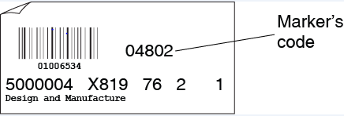
Open each packet carefully and check the centre details. If you receive a packet of scripts from your own centre, or from a centre with which you have connections, or which contains the script of a candidate you know, do not mark these scripts. The complete packet should be returned unmarked.
If you find any other discrepancies, return it with the first batch of marked scripts. Write ‘Special Attention’ on the outside of the packet and enclose a referral form, selecting the ‘Administrative’ option, and detail the issue.
If you are unsure of the issue and need to discuss, please telephone External Assessment Helpdesk on 0345 213 6612 (option 4) or email external.assessment@qualifications.gov.scot.

Marking scripts
If you have been asked to attend a markers’ meeting, all matters concerning the marking of scripts will be settled there. Finalised marking instructions will be agreed in the light of discussions that take place.
Any provisional marking that you have undertaken in preparation for the meeting must be reviewed and amended to conform to the agreed final instructions.

Marking arrangements
- Do not mark scripts in public premises or while you are travelling by public transport.
- Do not take scripts to any schools, colleges, or other public places.
- Please take all reasonable steps to ensure security of scripts.
- Give priority to packets with the greatest number of scripts, that is, mark those with ten scripts first, followed by those with nine, and so on.

Record of Marks and Despatch to Qualifications Scotland Form
As a safeguard against loss or damage to the scripts or mark sheets while they are in transit, it is important that you complete the Record of Marks and Despatch to Qualifications Scotland Form (see Appendix 3) with the information required. Copies of this are enclosed in your marker pack.
For each packet, enter the centre number and the group number on the Record of Marks and Despatch to Qualifications Scotland Form. You can find these details on the Attendance Register (see Appendix 1).
Enter the total marks for each candidate in the order they appear on the Attendance Register.
Where no script has been submitted for a candidate and the centre has noted the candidate as ‘ABS’ (absent), ‘W/D’ (withdrawn) or ‘To Follow’, transfer this information to the Record of Marks and Despatch to Qualifications Scotland Form. If no entry has been made, leave blank.
On the Record and marks and despatch form, record the consignment number in the section ‘Record consignment number here’. This is a 13-digit alpha numeric code which you can find on the Parcelforce label, just below the barcode.
Using the prepaid envelope supplied, post the forms back to Qualifications Scotland at the same time as your last batch of scripts (but separate from them), or to reach Qualifications Scotland no later than one week after your script return date.

Marker report
We will send you an email once the marking period has started; this will contain a link to a marker report form for you to complete. Please do this once you have finished marking your allocation.

Return of marked and unmarked scripts
It is essential for the smooth running of subsequent examination procedures that you return marked scripts in two batches within the marking period. We should receive the first batch of at least 50 scripts or half an allocation (whichever is less) seven days before the script return date. The remaining scripts must be returned in the second batch to reach us on or before the script return date.
If, because of unforeseen circumstances, it becomes clear that you will not be able to complete your marking by the due date, you must telephone the External Assessment Helpdesk on 0345 213 6612 (option 4) or email external.assessment@Qualifications.gov.scot immediately. Any unmarked scripts for return should be kept in their original packet, and you should write ‘Special Attention — Unmarked Scripts’ on the front of the packet and on the outside of the return bag. Please also enclose an explanatory note with the scripts concerned, using the ‘Administrative’ option on the referral form.
In your marker pack you are provided, a supply of pre-addressed Parcelforce return labels (see Appendix 5), and poly-envelopes for returning the packets of scripts. Please note that the address labels are only for use within Scotland.
All scripts must be returned to their original packet along with the corresponding attendance register.

Package up packets for return following the instructions below:
- Place the packets of scripts in the poly-envelope(s) provided

- Write your marker code number on the return label (refer to appendix 5)

- Remove the label from the backing paper

- Place the label on the poly-envelope

- On the Record of Marks and Despatch to Qualifications Scotland form, record each consignment number in the ‘Consignment number’ box. The consignment number can be found directly under the barcode on the Parcelforce label. These forms are provided in your Marker Pack.

- Your package can now be taken to a designated Post Office. To locate your nearest designated Post Office please refer to the Qualifications Scotland website at www.sqa.org.uk/markerinformation. Script delivery and return locations are listed under ‘Script Delivery’.

Should you have any enquiries regarding these instructions or require further supplies of Parcelforce return labels and poly-envelopes please contact Qualifications Scotland on 0345 213 6612 (option 4) or by e-mail at external.assesment@qualifications.gov.scot.

Additional information for central marking
Open each packet carefully and check the centre details. If you receive a packet of scripts from your own centre or from a centre with which you have connections, or which contains the script of a candidate you know, do not mark these scripts. Give the complete packet to the PA. It will be re-allocated to another marker.

Marker report
We will send you an email once the marking period has started; this will contain a link to a marker report form for you to complete. Please do this once marking at the central marking event has finished.

Appendices

Appendix 1: Attendance Register (mark sheet)
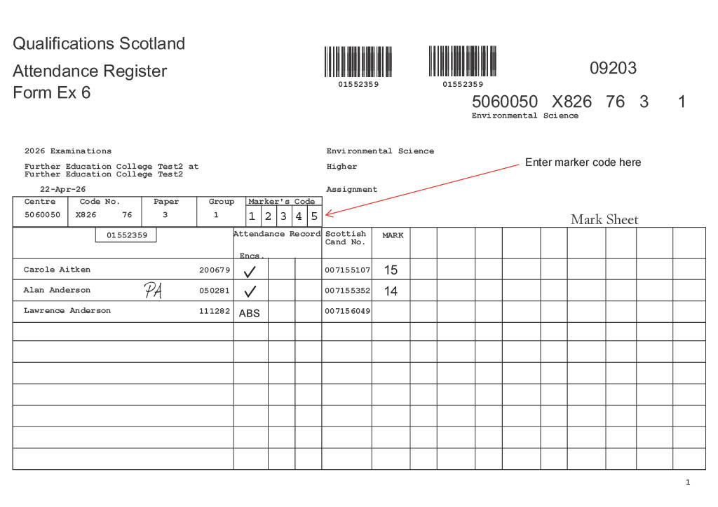

Appendix 2: Referral form
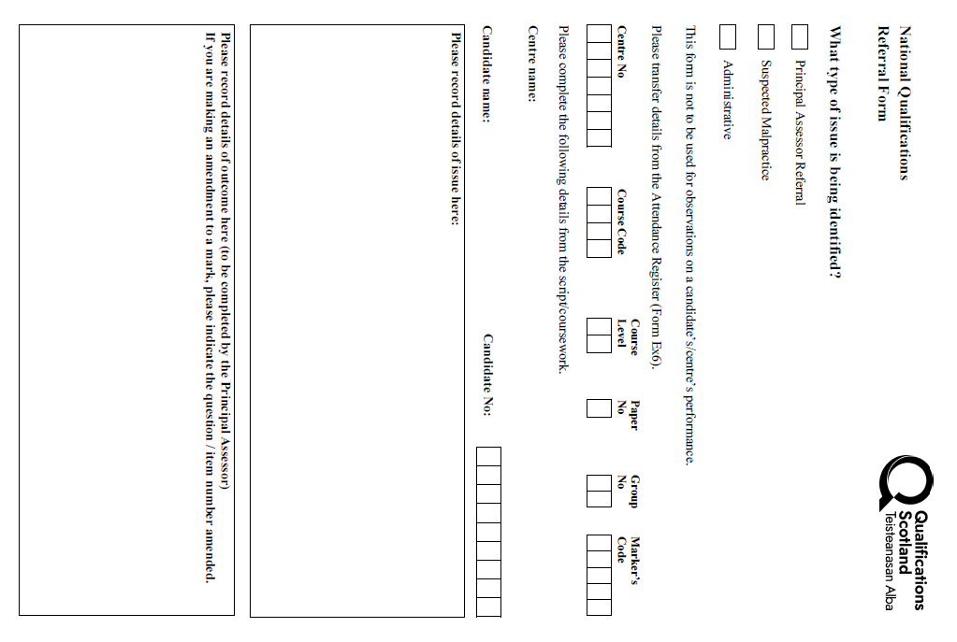

Appendix 3: Record of Marks and Despatch
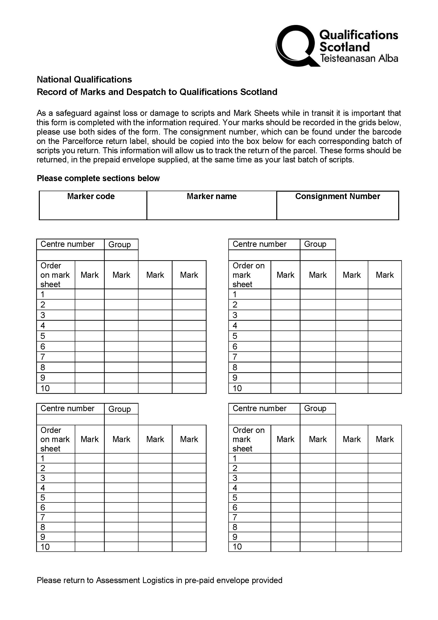

Appendix 4: Marker’s checklist
Marker’s checklist
Please use the following checklist to help you make sure that all appropriate actions have been taken.
All markers
My marker code matches the number on the packets of scripts I received
I have written my marker code on all the Attendance Registers (if you do not do this it could affect your payment)
The total mark has been entered in the ‘total mark’ box on the front of each script
The addition of marks on all scripts has been checked and is correct
The total mark on each script corresponds with the mark recorded against the relevant candidate on the Attendance Register Mark Sheet
All unmarked and ‘special attention’ scripts have been clearly identified in accordance with the guidelines
All scripts and their corresponding Attendance Registers have been returned to their original packets in the same order as the Attendance Register
My marker report has been completed and returned:
- Traditional marking — To Qualifications Scotland by email to external.assessment@qualifications.gov.scot
- Central marking — To the principal assessor, during marking event

Traditional markers
My first batch of scripts has been returned to Qualifications Scotland halfway through my marking period
My second batch of scripts has been returned to reach Qualifications Scotland on or before the script return date
My marker code and all marks are recorded on the Record of Marks and Despatch to Qualifications Scotland Forms
I have added the consignment details to the record of marks and despatch forms and returned the form to Qualifications Scotland in the envelope provided

Appendix 5: Return of examinations materials label
