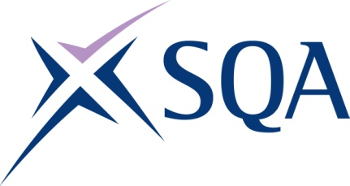

GK52 24 SVQ 4 Occupational Health and Safety Practice @ SCQF level 9
To attain the qualification candidates must complete 10 Units in total. This comprises:

10 mandatory Units

Please note the table below shows the SSC identification codes listed alongside the corresponding SQA Unit codes. It is important that the SQA Unit codes are used in all your recording documentation and when your results are communicated to SQA.

Mandatory Units: Candidates must complete 7 Units from this group
SQA code | SSC code | Title | SCQF level | SCQF credits
H8WA 04 | PROHSP2 | Promote a Positive Health and Safety Culture | 9 | 5
H8WC 04 | PROHSP3 | Develop and Implement the Health and Safety Policy | 9 | 14
H8WD 04 | PROHSP4 | Develop and Implement Effective Communication Systems for Health and Safety Information | 9 | 8
H8WE 04 | PROHSP5 | Develop and Maintain Individual and Organisational Competence in Health and Safety Matters | 9 | 10
H8WF 04 | PROHSP6 | Control Health and Safety Risks | 9 | 18
H8WG 04 | PROHSP7 | Develop, Implement and Review Proactive Monitoring Systems for Health and Safety | 9 | 10
H8WH 04 | PROHSP8 | Develop, Implement and Review Reactive Monitoring Systems for Health and Safety | 10 | 15
H8WJ 04 | PROHSP10 | Develop and Implement Health and Safety Emergency Response Systems and Procedures | 9 | 12
H8WK 04 | PROHSP11 | Develop and Implement Health and Safety Review Systems | 9 | 8
H8WL 04 | PROHSP13 | Influence and Keep Pace with Improvements in Health and Safety Practice | 9 | 8

