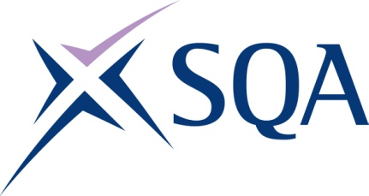
GR8T 22 | SVQ Level 2 Offshore Deck Operations

SCQF overall credit: Minimum 0 Maximum 0

To attain the qualification candidates must complete 6 units in total. This comprises:

- 4 mandatory units
- 2 optional units

Please note the table below shows the SSC identification codes listed alongside the corresponding SQA unit codes. It is important that the SQA unit codes are used in all your recording documentation and when your results are communicated to SQA.

Mandatory units: Candidates must complete all 4 units from this group
SQA code | SSC code | Title | SCQF level | SCQF credits
F229 04 | COGODR2 | Establish and Maintain Effective Relationships with Others | Unlevelled | Unlevelled
J578 04 | COGPOH1 | Contribute to the Health and Safety of the Working Environment | Unlevelled | Unlevelled
D9A6 04 | COGODO3 | Carry Out Slinging and Lifting for the Movement of Loads | Unlevelled | Unlevelled
D7X0 04 | COGODR1 | Contribute to Safety, Health and Environmental Protection | Unlevelled | Unlevelled

Optional units: Candidates must complete 2 units from this group
SQA code | SSC code | Title | SCQF level | SCQF credits
F222 04 | COGODO5 | Contribute to Helicopter Handling Operations | Unlevelled | Unlevelled
F223 04 | COGODO6 | Contribute to Helicopter Refuelling Operations | Unlevelled | Unlevelled
F221 04 | COGODO7 | Carry Out General Cleaning Operations | Unlevelled | Unlevelled

