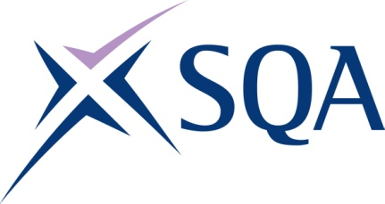
GR8N 21 | SVQ Level 1 Processing Operations: Hydrocarbons

SCQF overall credit: Minimum 0 Maximum 0

To attain the qualification candidates must complete 5 units in total. This comprises:

- 5 mandatory units

Please note the table below shows the SSC identification codes listed alongside the corresponding SQA unit codes. It is important that the SQA unit codes are used in all your recording documentation and when your results are communicated to SQA.

Mandatory units: Candidates must complete all 5 units from this group
SQA code | SSC code | Title | SCQF level | SCQF credits
J578 04 | COGPOH1 | Contribute to the Health and Safety of the Working Environment | Unlevelled | Unlevelled
J579 04 | COGPOH3 | Assist with the Control of Emergencies and Critical Situations | Unlevelled | Unlevelled
J57A 04 | COGODO1 | Establish and Maintain Effective Working Relationships with Others | Unlevelled | Unlevelled
J57B 04 | COGPOH8 | Start Up and Shutdown a Process System | Unlevelled | Unlevelled
J57C 04 | COGPOH9 | Monitor a Process System | Unlevelled | Unlevelled

