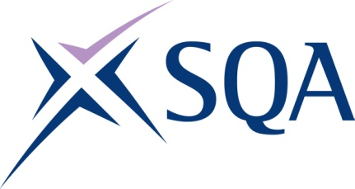
GR8P 23 | SVQ Level 3 Processing Operations: Hydrocarbons (Control Room)

SCQF overall credit: Minimum 0 Maximum 0

To attain the qualification candidates must complete 7 units in total. This comprises:

- 7 mandatory units

Please note the table below shows the SSC identification codes listed alongside the corresponding SQA unit codes. It is important that the SQA unit codes are used in all your recording documentation and when your results are communicated to SQA.

Mandatory units: Candidates must complete all 4 units from this group
SQA code | SSC code | Title | SCQF level | SCQF credits
J57D 04 | COGPOH2 | Monitor and Maintain Health, Environment and Safety Systems | Unlevelled | Unlevelled
J57E 04 | COGEL3 | Control Emergencies and Critical Situations | Unlevelled | Unlevelled
J57F 04 | COGPOH7 | Create, Maintain and Enhance Productive Working Relationships | Unlevelled | Unlevelled
J57G 04 | COGPOHCR4 | Prepare Integrated Process Systems for Remote Control Operation | Unlevelled | Unlevelled
J57H 04 | COGPOH19 | Remotely Control Integrated Process Systems | Unlevelled | Unlevelled
J57J 04 | COGPOH20 | Prepare and Shut Down Remote Integrated Process Systems | Unlevelled | Unlevelled
J57K 04 | COGPOHCR7 | Facilitate the Maintenance of Process Plant and Equipment | Unlevelled | Unlevelled

