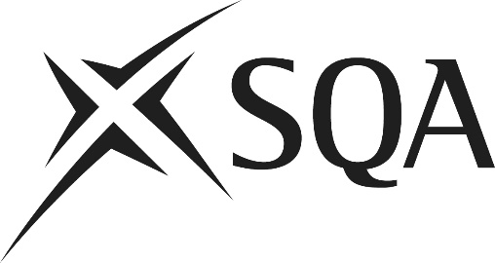

National Qualifications 2026

Advanced Higher History

Alternative titles for dissertations
Part of the external assessment for Advanced Higher History requires candidates to submit a project−dissertation. This may be drawn from the content of their Field of Study, but candidates are free to research any complex historical issue. A list of suggested titles is available on the subject page of SQA’s website. Where candidates devise an alternative title, centres may submit titles for feedback. This service is advisory in nature.

Centres who wish to present dissertation titles that are not included on the list may submit the proposed title to SQA via the dissertation mailbox (dissertation@sqa.org.uk) by 3 November 2025.

Centre name: |  |  | Centre number:
Scottish
Candidate Number:
Candidate name: |  |  | Scottish  Candidate Number:

Proposed title

Scope of the proposed dissertation

Teacher or lecturer responsible: |  | Date:
SQA Co-ordinator: |  | Date:

For official use:

Examiner’s comments:

