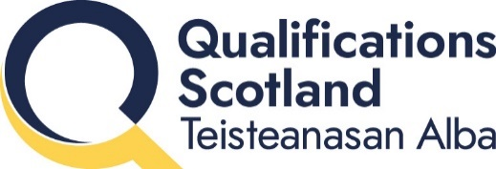

Group Award Title: SVQ Exercise and Fitness at SCQF level 6
Group Award Code: GI0X 23
SCQF overall credit: Minimum: 30 Maximum: 32
To attain the qualification, candidates must complete FIVE units. This consists of:
- 3 mandatory plus 2 options

Please note the tables show the SSC identification codes listed alongside the corresponding Qualifications Scotland unit codes. It is important that Qualifications Scotland unit codes are used in all your recording documentation, and when your results are communicated to Qualifications Scotland.

Mandatory units: Candidates must complete all 3 units
Qualifications Scotland code | SSC code | Title | SCQF level | SCQF credits | Qualifications Scotland credits
JAZ3 04 | SKAEAF1 | Contribute to Health and Safety in Active Leisure Environments | 5 | 4 | 1
JK5U 04 | SKALO10 | Reflect On and Improve Your Work Practice | 6 | 4 | 1
JVJY 04 | SKAEAF22 | Review and Improve Activity Sessions | 6 | 5 | 1

Options:
1 Group, 2 units required

Optional group A: 2 units required
Qualifications Scotland code | SSC code | Title | SCQF level | SCQF credits | Qualifications Scotland credits
J7UE 04 | SKAEAF4 | Plan Individual and Small Group Exercise and Fitness Sessions | 6 | 7 | 1
JYWG 04 | SKAEAF5 | Instruct Individual and Small Group Exercise and Fitness Sessions | 6 | 10 | 1

Optional group B: 2 units required
Qualifications Scotland code | SSC code | Title | SCQF level | SCQF credits | Qualifications Scotland credits
J7OA 04 | SKAEAF10 | Plan Group Exercise Sessions | 6 | 7 | 1
JYSO 04 | SKAEAF11 | Instruct Group Exercise Sessions | 6 | 10 | 1

Optional group C: 2 units required
Qualifications Scotland code | SSC code | Title | SCQF level | SCQF credits | Qualifications Scotland credits
JDL6 04 | SKAEAF6 | Plan Exercise and Physical Activity Sessions for Children | 7 | 8 | 1
JF4I 04 | SKAEAF7 | Instruct Exercise and Physical Activity Sessions for Children | 7 | 11 | 1

Template version: March 2026

