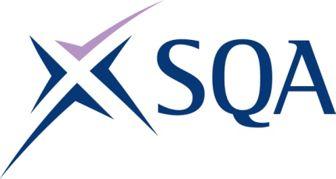
Group Award Title: Diploma in Engineering: Engineering Asset Lifecycle and Maintenance at SCQF level 7
Group Award Code: GV31 47
SCQF overall credit: Minimum: 171 Maximum: 228
To attain the qualification, candidates must complete 7 Units. This consists of:

- 3 Mandatory units
- 4 Optional units

Please note the table below shows the SSC identification codes listed alongside the corresponding SQA unit codes. It is important that SQA unit codes are used in all your recording documentation, and when your results are communicated to SQA.

Mandatory section (three units): Candidates must complete all three units:
SQA code | SSC code | Title | SCQF  level | SCQF  credits | SQA  credits
J7JP 47 | SDS0323 | Performing Core Engineering Activities | 7 | 37 | 1
J7JR 46 | US0194 | Developing Meta-Skills and Personal Practice | 6 | 5 | 1
J7JS 47 | SDS0329 | Understanding the Importance of Environmental Good Practice and Sustainability | 7 | 12 | 1

Optional group:

Candidates must complete a further three units from Group A plus one further unit from Group A or Group B (Total: seven units)

Group A:
SQA code | SSC code | Title | SCQF  level | SCQF  credits | SQA  credits
J7JT 47 | SDS0321 | Maintaining Engineering Assets | 7 | 42 | 1
J7JV 47 | SDS0315 | Diagnosing and Resolving Faults in Engineering Assets | 7 | 45 | 1
J7JW 47 | SDS0326 | Repairing Engineering Assets | 7 | 37 | 1
J7JX 47 | SDS0327 | Replacing Engineering Assets | 7 | 42 | 1
J7JY 47 | SDS0317 | Inspecting and Testing Engineering Assets | 7 | 45 | 1
J7K0 47 | SDS0318 | Installing Engineering Assets | 7 | 38 | 1
J7K1 47 | SDS0310 | Commissioning Engineering Assets | 7 | 38 | 1
J7K2 47 | SDS0314 | Decommissioning Engineering Assets | 7 | 36 | 1
J7K3 47 | SDS0322 | Manufacturing Engineering Assets by Hand | 7 | 32 | 1

Group B:
SQA code | SSC code | Title | SCQF  level | SCQF  credits | SQA  credits
J7K4 47 | SDS0324 | Producing Assemblies and Sub-Assemblies | 7 | 36 | 1
J7K5 48 | SDS007 | Applying Methods and Principles in Project Management | 8 | 12 | 1
J7KB 47 | SDS0331 | Welding Materials | 7 | 35 | 1
J7KD 48 | SDS188 | Providing Effective Leadership | 8 | 16 | 1

