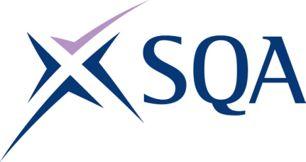

# Group Award Title: Diploma in Accounting at SCQF level 6

## Group Award Code: GV9L 46

### SCQF overall credit: Minimum: 50 Maximum: 55

To attain the qualification, candidates must complete five units. This consists of:

* four mandatory units and
* one optional unit

Please note the following tables show the SSC identification codes listed alongside the corresponding SQA unit codes. It is important that SQA unit codes are used in all your recording documentation, and when your results are communicated to SQA.

Core units: All four mandatory units must be taken with the required optional units as set out in the following tables:

| SQA code | SSC code/ SDS code | Title | SCQF level | SCQF Credit points | SQA Unit credits |
| --- | --- | --- | --- | --- | --- |
| J8XF 46 | SDS 0487 | Applying Principles of Accounting Operations | 6 | 10 | 1 |
| J8XG 47 | SDS 0488 | Applying Principles of Management Accounting | 7 | 15 | 1 |
| J8XH 46 | SDS 0490 | Handling Financial Transactions | 6 | 10 | 1 |
| J8XJ 46 | US0194 | Developing Meta-Skills and Personal Practice | 6 | 5 | 1 |

## Additional structural information

The qualification consists of three mandatory accounting units, one mandatory  
meta-skills unit together with one optional accounting unit selected from a choice of three.

## Additional credit rating information

SCQF level 6 is the dominant level across the units with two out of three of the mandatory accounting units at SCQF level 6.

Optional units: Complete at least one optional unit from the following table:

| SQA code | SSC code/ SDS code | Title | SCQF level | SCQF Credit points | SQA Unit credits |
| --- | --- | --- | --- | --- | --- |
| J8XK 46 | SDS 0491 | Producing Financial Information and Forecasts | 6 | 10 | 1 |
| J8XL 46 | SDS 0489 | Carrying Out VAT Administration | 6 | 10 | 1 |
| J8XM 46 | SDS 0492 | Providing Personal Tax Administration | 6 | 15 | 1 |

Template version: May 2025