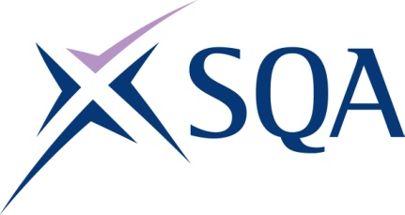

# Group Award Title: Diploma in Accounting at SCQF level 8

## Group Award Code: GV9M 48

### SCQF overall credit: Minimum: 56 Maximum: 58

To attain the qualification, candidates must complete four units. This consists of:

* three mandatory units and
* one optional unit

Please note the following tables show the SSC identification codes listed alongside the corresponding SQA unit codes. It is important that SQA unit codes are used in all your recording documentation, and when your results are communicated to SQA.

Core units: All three mandatory units must be taken with the required optional units as set out in the following tables:

| SQA code | SSC code/ SDS code | Title | SCQF level | SCQF Credit points | SQA Unit credits |
| --- | --- | --- | --- | --- | --- |
| J8XN 48 | SDS 0493 | Providing Management Accounting Services | 8 | 15 | 1 |
| J8XP 48 | SDS 0494 | Performing Financial Accounting | 8 | 15 | 1 |
| J8XR 48 | SDS 012 | Developing Meta-Skills and Personal Professionalism | 8 | 16 | 1 |

## Additional structural information

The qualification consists of two mandatory accounting units, one mandatory  
meta-skills unit together with one optional accounting unit selected from a choice of two.

## Additional credit rating information

SCQF level 8 is the dominant level across the units with all three of the mandatory accounting units at SCQF level 8.

Optional units: Complete at least one optional unit from the following table:

| SQA code | SSC code/ SDS code | Title | SCQF level | SCQF Credit points | SQA Unit credits |
| --- | --- | --- | --- | --- | --- |
| J8XT 47 | SDS 0495 | Preparing Financial Statements | 7 | 10 | 1 |
| J8XV 48 | SDS 0496 | Providing Business Taxation Services | 8 | 12 | 1 |

Template version: May 2025