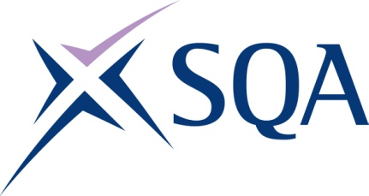
Group Award Title: SVQ in Formwork (Construction) (Formwork Erector and Striker) at SCQF Level 5
Group Award Code: GW14 22
SCQF overall credit: 54
To attain the qualification, candidates must complete five Units. This consists of:

- 5 mandatory units

Please note the table below shows the SSC identification codes listed alongside the corresponding SQA unit codes. It is important that SQA unit codes are used in all your recording documentation, and when your results are communicated to SQA.

Mandatory units: Candidates must complete all 5 units
SQA code | SSC code | Title | SCQF  level | SCQF  credits | SQA  credits
FN2J 04 | COSVR641 v2 | Conform to General Workplace Health, Safety and Welfare | 6 | 12 | 1
HL7T 04 | COSVR642 v1 | Conform to Productive Work Practices | 5 | 5 | 1
HM15 04 | COSVR643 v1 | Move, Handle or Store Resources | 5 | 5 | 1
J988 04 | COSVR510 v3 | Erect and Strike Timber and Proprietary Formwork | 5 | 20 | 1
J989 04 | COSVR787 v3 | Maintain Timber and Proprietary Formwork | 5 | 12 | 1

Template version: December 2022.

