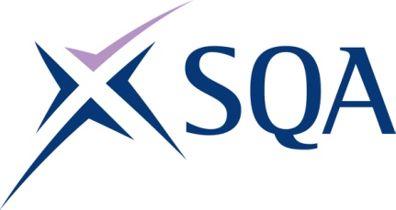

Level 2 Award in Asbestos Awareness

SQA Qualification Code: GV80 62

Regulation Qualification Code: 610/5387/9

Total Qualification Time: 20 hours

Minimum Guided Learning Hours (GLH) for whole qualification: 15 hours

To achieve this qualification, learners will need to complete a minimum total of 2 credits.

This comprises:

* 2 mandatory core credits

**Please note:** It is important that SQA unit codes are used in all your recording documentation, and when your results are communicated to SQA.

# Mandatory Core units: Learners must achieve all 2 credits from this group:

| **SQA**  **Unit code** | **Title** | **Credit**  **value** | **Level** | **GLH** | **Regulated**  **Unit code** |
| --- | --- | --- | --- | --- | --- |
| J8RM 62 | Asbestos Awareness | 2 | 2 | 15 | J/651/5120 |

Template version: December 2022.