

Scottish Studies Award

Scotland in Focus workbook

The information in this workbook may be reproduced in support of SQA qualifications only on a non-commercial basis. If it is reproduced, SQA must be clearly acknowledged as the source. If it is to be reproduced for any other purpose, written permission must be obtained from permissions@sqa.org.uk.

Published: September 2025 (version 1.0)
© Scottish Qualifications Authority 2025

Scottish Studies: Scotland in Focus at SCQF levels 3 to 6

Candidate record
Candidate’s name | Candidate’s Scottish candidate number (SCN) number | Teacher or lecturer’s name

Unit code and level | Mark with a cross (X)
H3YP 43 — level 3
H3YP 44 — level 4
H3YP 45 — level 5
H3YP 46 — level 6

Contents
Scotland in Focus workbook 1
Scottish Studies: Scotland in Focus at SCQF levels 3 to 6 2
Candidate record 2
Assessment 1
Candidate brief 1
Outcome 1 5
1.1 Planning your aim or aims 5
1.2 Activity 9
1.3 Sources and resources 13
1.4 Selecting information: note-making 18
1.5 Completing your activity 25
Outcome 2 evaluation 27
Candidate evidence checklist 30
Scottish Studies: Scotland in Focus at SCQF levels 3 to 6 30
Marking scheme and assessor’s checklist 35
Scottish Studies: Scotland in Focus at SCQF levels 3 to 6 35
Copyright acknowledgements 41
Administrative information 42
History of changes 42

Assessment

Candidate brief

Introduction

For this unit, you need to plan and complete an activity that can help you to learn about an aspect of Scotland that is of interest to you. This might involve, for example, finding out about:
- a famous Scottish person, place or invention
- Scottish music, art, literature or architecture
- Scottish communities at home or abroad
- people, circumstances or events that have influenced Scottish culture
You can complete this unit at levels: level 3, 4, 5 or 6. Each of these have slightly different requirements.
- At levels 3 and 4, you identify what you find out from your activity, and you should communicate this information appropriately. Level 3 can be basic, but level 4 must provide some detail.
- At levels 5 and 6, you also need to analyse what you find out from your activity, and communicate this effectively and in detail. There are lots of ways you can communicate what you find out — your teacher or lecturer can give you advice to help you choose the best way to do this.
- At level 6 only: once you have completed your activity; and identified, analysed and communicated what you found out; you need to evaluate your process and the effectiveness of your communication method.
The following breakdown by stage should help you to complete everything you need to do for this unit. Your teacher or lecturer may also give you additional advice at certain points to help you stay on track.

Stage 1: Planning your activity
To plan your activity, you must make the following decisions.
- What aspect(s) of Scotland do you want to learn about? These will be your aim(s) throughout the unit.
  - Levels 3 and 4: one aim
  - Levels 5 and 6: two connected aims
Your teacher or lecturer can give you feedback on your aims and activities at the planning stage.
- What you’re going to do to learn about these aspects of Scotland and how you’re going to communicate what you learn. This is the activity you need to complete during the unit, and could include:
  - carrying out research from books, journals and online
  - watching documentaries
  - interviewing people
  - creating a poster or digital display
  - creating a graphic novel, animation, film, play or performance
  - putting on an event
  - creating a talk, doing a presentation or having a discussion
  - writing a report, information booklet or essay
  - or any other suitable activity, in agreement with your teacher or lecturer
- The sources of information and the resources you’re going to need to complete your activity.
  - Level 3: you must agree with your lecturer what information and resources (at least two) you’re going to use.
  - Level 4: you must choose at least two sources of information and resources from a selection your teacher or lecturer gives you.
  - Levels 5 and 6: you must independently identify at least three sources of information.

Stage 2: Completing your activity
Once you have chosen your aim, activity, sources and resources, you can begin your activity.
- Use your sources to choose information that is relevant to your aim — the aspect(s) of Scotland you want to learn about.
- Use this information and your chosen resources to help you complete your activity.
- Stay focused on your aim(s) throughout — the specific aspect(s) of Scotland you have chosen to learn about.
- Each of the levels have slightly different requirements, these are:
  - Level 3: identify the basic information you learn
  - Level 4: identify what you learn in some detail
  - Level 5: analyse the information in detail
  - Level 6: analyse your information in depth
- For all levels, you should communicate this information appropriately. You must make sure that you do not lift information straight from the source without either putting it into your own words or identifying it as a quotation from a source. Failing to do so can count as plagiarism and mean that you do not pass this unit.

Stage 3: Identifying and communicating your findings
Once you have completed your activity, you need to check that the evidence you collect throughout communicates what you have learned about your chosen aspects of Scotland. For example, you may have:
- produced a report, booklet or online webpage that contains all the information about what you have learned
- delivered an electronic presentation with slides and speaker’s notes that clearly show what you have learned
- put on a performance and kept a workbook or log of what you learned as you planned and developed the performance
- created art or craft work and kept notes about what you have learned as you planned and created it
Your teacher or lecturer can confirm any part of your activity that they have observed, if necessary. They can also confirm that all the evidence you have presented is your own work.
You can use the Candidate Evidence Checklist to check that you have all the evidence you need.

Outcome 1

Planning your aim or aims

Your aim must be to find out something new about Scotland that you didn’t know before. The activity is how you intend to find it out and demonstrate your new knowledge. At levels 3 and 4, you should have one aim. At levels 5 and 6, you should have two connected aims.
You can frame these like learning intentions, for example: ‘I will learn about…’
Topics you could choose include:
- The wealth and poverty ratio in different areas of Scotland.
- The history of the Old Firm football rivalry or the impact of the Old Firm games on crime rates.
- The drug culture, health issues and crime rates in Scotland.
- The history of Scottish music focusing on a particular Scottish band or musician.
- Scottish sporting heroes.
- Myths, legends and superstitions in Scottish culture or Scottish witch trials.
- The history of a Scottish city or town.
- How Scots are represented in the media.
- The history of the Scots language.

Write your aim(s) here:
Overall topic

Aims | I am going to learn about:
Aim 1 (level 3 and level 4)
Aim 2 (level 5 and level 6)

I chose my aim or aims… | Yes or No | I have one aim… | Yes or No | I have two aims… | Yes or No
…by discussing them with my teacher or lecturer (level 3). |  | that I choose from a given list  (level 4). |  | …that I choose independently (level 5 or 6).

Assessment standard achieved | Mark with a cross (X)
Assessment standard 1.1

Assessor’s signature | Date | Cross marked by | Date

Assessor comments | Internal verifier comments
Please attach any additional comments on a separate piece of paper.

Making a research plan
This can help you keep on track, and helps your teacher or lecturer see your approach.
Why have I chosen this topic?

What would I like to find out? (4 or 5 questions)

What sources could I use?

Why is this an important or interesting topic?

Activity
How are you going to find out about and then present your information?

Your teacher or lecturer may need you to do particular activities, or you may have free choice in what you can do as your activity. If you are being asked to do a report or a talk, for example, you should also try to do something of your own choice to help you prepare for this.
In the following table, we give suggestions of activities you could consider.
Activity | Requirements
Gathering information:  researching in books and online | Keep your research notes and details of where the information comes from.
Gathering information:  watching documentaries | Keep details of what you watch, and notes you take.
Gathering information:  interviewing people | Keep your interview questions and notes, and/or a transcript of the interview.
Presenting information:  creating a poster or digital display | Consider if this, as a final product, includes enough detail for the level you are aiming for. If l not, you must also keep research notes and/or take part in a discussion about the information you discover.
Presenting information:  creating a graphic novel, animation, film, play or performance | Keep your research notes and details of where the information comes from. Explain how this information affects your planning and preparation for the activity. Present your finished product.
Presenting information:  putting on an event | Keep your research notes and details of where the information comes from. Explain how this information affects your planning and preparation for the event.
Presenting information:  creating a talk, doing a presentation or  having a discussion | Keep your research notes as well as a script or detailed notes about what you say during the presentation. Presentation slides often don’t have enough detail on their own.
Presenting information:  writing a report, information booklet or essay | Make sure you use your own words, or that you indicate when you use quotations lifted directly from a source.
…or any other suitable activity,  in agreement with your teacher or lecturer | In discussion, make sure you give enough detail to pass the level you are aiming for.

If your teacher or lecturer needs you to complete a particular activity, write this down here:

Levels 4 to 6
If you are asked to complete an activity, such as a report or a presentation, what other tasks you are you going to build into the process to make sure you can pass at the appropriate level?

Activities | Yes or No
Are you doing a presentation or talk?
Are you involved in a discussion after you have presented your information?
Are you doing a question and answer session?

How are you keeping note of what is said in these talks or discussions?

I chose my activity/  activities… | Yes or No | I have one activity… | Yes or No | I have two activities… | Yes or No
…in discussion my teacher or lecturer (level 3) |  | …that I chose from a list (level 4) |  | … that I chose independently  (level 5/6)

Assessment standard achieved | Mark with a cross (X)
Assessment standard 1.2

Assessor’s signature | Date | Cross marked by | Date

Assessor comments | Internal verifier comments
Please attach any additional comments on a separate piece of paper.

Sources and resources

Sources
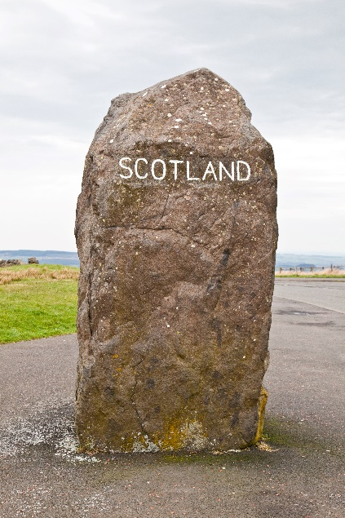
You must explain what sources you use during your activity. You use these sources to find information which is relevant to your aims.
- For level 3, agree these resources with your teacher or lecturer.
- For level 4, select resources from a list provided.
- For level 5 and 6, it is important you do this without help from your teacher or lecturer. However, teachers or lecturers can respond to direct questions if required.
Appropriate sources of information could include:
- relevant websites, factual or reference books in hard-copy or electronic format, such as e-books and audiobooks
- individuals or groups with a specific expertise or interest, seminars or presentations from external speakers
- brochures, journals, newspapers or information booklets, specialist catalogues and magazines
- television or radio programmes, or recorded information
- field trips, visits, exhibitions

Make a note of your sources here:
Source  (Title, author, date, full web address) | Comment on usefulness of the source (Assessment standard 2.1)

Resources
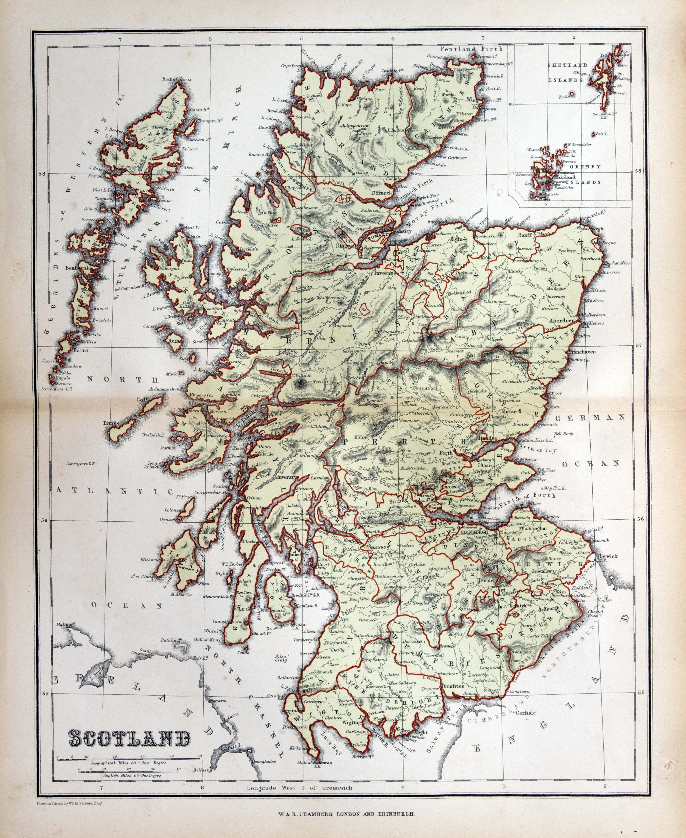
Identify the resources you use to help you find information.
- For level 3, agree these resources with your teacher or lecturer.
- For level 4, select resources from a list provided.
- For level 5 and 6, it is important you do this without aid from your teacher or lecturer. Teachers or lecturers can respond to direct questions if required, however.
Appropriate resources could include:
- the library; using an iPad, laptop or home computer; the internet
- a person or group with a specific interest or expertise
- stationery items like paper, pens, highlighters, glue and scissors
- television, radio, DVD player
- art supplies like paint, brushes, charcoal and marker pens…
- musical instruments, musical scores
- cooking equipment and ingredients
- costumes and props

Make a note of your resources here:
Source  (Title, author, date, full web address) | Usefulness of the source (Assessment standard 2.1)

I chose my sources and resources… | Yes or No | I have two sources… | Yes or No | I have three or more sources… | Yes or No
…by agreeing them with my teacher or lecturer (level 3) |  | …that I chose from a list (level 4) |  | …that I chose independently (level 5/6)

Assessment standard achieved | Mark with a cross (X)
Assessment standard 1.3

Assessor’s signature | Date | Cross marked by | Date

Assessor comments | Internal verifier comments
Please attach any additional comments on a separate piece of paper.


Selecting information: note-making
Please remember not to copy directly from your source — taking notes means small chunks in your own words. Write down key facts. Always write down where you get your information from. Use this table to help you. If you need to copy and paste from the source, make sure to use “ ” to show where you use quotations.

Source 1
Info | Description
Title
Author, publisher
Full web address, date accessed

Key points and main ideas of source 1
Bullet points, abbreviations, shortened versions, key points, ideas and facts, using your own words or quoting properly if appropriate.

Evaluating what you found out
What do you think of what you have read? What is important? What is most interesting? Did this change your opinions? What is the most valuable fact?

Source 2
Info | Description
Title
Author, publisher
Full web address, date accessed

Key points and main ideas of source 2
Bullet points, abbreviations, shortened versions, key points, ideas and facts, using your own words or quoting properly if appropriate.

Evaluating what you found out
What do you think of what you read? What is important? What is most interesting? Did this change your opinions? What is the most valuable fact?

Source 3
Info | Description
Title
Author, publisher
Full web address, date accessed

Key points and main ideas of source 3
Bullet points, abbreviations, shortened versions, key points, ideas and facts, using your own words or quoting properly if appropriate.

Evaluating what you found out
What do you think of what you read? What is important? What is most interesting? Did this change your opinions? What is the most valuable fact?

How I chose my information | Mark with a cross (X)
I used agreed information (level 3)
The information is relevant (level 4 or 5)
I researched the information (level 5 or 6)
The information is sufficiently detailed (level 6)

Assessment standard achieved | Mark with a cross (X)
Assessment standard 1.4

Assessor’s signature | Date | Cross marked by | Date

Assessor comments | Internal verifier comments
Please attach any additional comments on a separate piece of paper.

Completing your activity
Once you have completed your research, make sure you have taken good notes in your own words, and that you have acknowledged your sources.
You should now write a report that clearly communicates what you learned about your Scottish topic.
You must use your own words throughout.

Your activity must show:
- why you chose the topic
- what your aims are
- where you got your research information: your sources and resources
- what you learned about your Scottish focus (it must be distinctly Scottish)
- why you think it is important and worth studying
- how useful your research sources were
It is helpful to also include a bibliography at the end.
Do not plagiarise — you must use your own words at all times!

I used information to complete my activity and achieve my aim | Mark with a cross (X)
I used chosen information (level 4)
By using information, I identified (level 5)
By using detailed information, I identified (level 6)

Assessment standard achieved | Mark with a cross (X)
Assessment standard 1.5

Assessor’s signature | Date | Cross marked by | Date

Assessor comments | Internal verifier comments
Please attach any additional comments on a separate piece of paper.

Outcome 2 evaluation
Question | Notes for my answer | Teacher or lecturer comments
Why did you choose the topic?
What new information did you learn about the topic?

Did anything surprise you?

Was there anything you weren’t expecting?
What do you think was important about this topic?

Why is it interesting or
important?
Did you have to change anything about your plan as you went along?
Was there anything you couldn’t find information about?

Was there anything you still want to know more about?
How effective were your research skills?

What would you do differently next time?
Would you recommend this topic?

Why?

Why not?
How useful were your sources?

Could you get everything you needed from them?

Did you need to look elsewhere to get more information?
What resources were the most helpful?

What other resources did you need to add as you went along?
Level 6 candidates should now go on to write up this evaluation in detail.

Candidate evidence checklist

Scottish Studies: Scotland in Focus at SCQF levels 3 to 6

assessment standard
I chose my aim or aims… | Yes or No | I chose my aim or aims… | Yes or No | I chose my aim or aims… | Yes or No
…by discussing them with my teacher or lecturer (level 3). |  | …that I choose from a given list (level 4) |  | …that I choose independently (level 5 or 6).

My aims

assessment standard
I chose my activity or activities… | Yes or No | I chose my activity or activities… | Yes or No | I chose my activity or activities… | Yes or No
…in discussion my teacher or lecturer (level 3) |  | …that I chose from a list (level 4) |  | … that I chose independently  (level 5/6)

My activity or activities

assessment standard
I chose my sources and resources… | Yes or No | I have two sources… | Yes or No | I have three or more sources… | Yes or No
…by agreeing them with my teacher or lecturer (level 3) |  | …that I chose from a list (level 4) |  | … that I chose independently  (level 5/6)

My main sources are:

Resources | Yes or No
I chose the resources I needed to complete the activity

My main resources were:

assessment standard
Level | Assessment standard | Yes or No
Level 3 | I used agreed information to complete my activity and achieve my aim
Level 4 | I used selected information
Level 4, 5 or 6 | I used relevant information
Level 5 or 6 | I researched and selected information
Level 6 | I used detailed information

assessment standard
I used the sources of information to achieve my aim.
Level | Assessment standard | Yes or No
Level 4 | I chose sources
Level 5 or 6 | I identified sources
Level 6 | I used detailed sources

assessment standard
I used the information and resources to complete the activity and achieve my aims.
Level | Assessment standard | Yes or No
Level 3 | I identified basic information
Level 4 | I identified information in some detail
Level 5 | I analysed information in sufficient detail
Level 6 | I analysed information in sufficient depth

assessment standard
I communicated what I learned in an appropriate way and in an appropriate level of detail.
Level | Assessment standard | Yes or No
Level 3 | I communicated what I learned appropriately
Level 4 | I communicated what I learned clearly and appropriately
Level 5 | I communicated what I learned effectively and appropriately
Level 6 | I communicated what I learned effectively and in detail

assessment standard
Level | Assessment standard | Yes or No
Level 6 | I evaluated the process I followed and the effectiveness of my chosen method of communication

Candidate’s signature | Date

Marking scheme and assessor’s checklist

Scottish Studies: Scotland in Focus at SCQF levels 3 to 6
Candidate’s name

Outcome 1: Plan and complete an activity that has a Scottish Focus

assessment standard — aims and activities.
The candidate:
Level | Assessment standard | Mark with a cross (X)
Level 3 | agreed one aim that broadens their knowledge of Scotland
Level 4 | chose one aim that broadens their knowledge of Scotland
Level 5 | independently chose two linked aims that broaden their knowledge of Scotland
Level 6 | independently chose two linked aims that broaden and deepen their knowledge of Scotland

assessment standard — activity.
The candidate:
Level | Assessment standard | Mark with a cross (X)
Level 3 | agreed an activity to help them achieve their aim
Level 4 | chose an activity to help them achieve their aim from a range of potential aims
Level 5 | independently chose an activity to help them achieve their aims
Level 6 | independently chose an activity to help them achieve their aims

assessment standard — sources and resources.
The candidate:
Level | Assessment standard | Mark with a cross (X)
Level 3 | agreed at least two sources of information/the resources they needed to complete the activity
Level 4 | chose at least two sources of information/the resources they needed to complete the activity
Level 5 | independently chose at least three sources/the resources they needed to complete the activity.
Level 6 | independently chose at least three detailed sources/the resources they needed to complete the activity.

assessment standard — selecting information.
The candidate:
Level | Assessment standard | Mark with a cross (X)
Level 3 | used the agreed information and resources to complete the activity and achieve their aim
Level 4 | selected relevant information from their chosen sources
Level 5 | researched and selected relevant information from the sources and resources they identified
Level 6 | researched and selected detailed information from the sources and resources they identified

assessment standard — using information and completing the activity.
The candidate:
Level | Assessment standard | Mark with a cross (X)
Level 4 | used the chosen sources of information to achieve their aim
Level 5 | used the information and resources they identified to complete the activity and achieve their aims
Level 6 | used the detailed information and resources they identified to complete the activity/achieve their aims

assessment standard — independence level SCQF 6.
The candidate:
Level | Assessment standard | Mark with a cross (X)
Level 6 | worked independently throughout

Outcome 2: Reflect on what I have learned about my Scottish focus during the activity by

assessment standard — reflecting on what has been learned.
The candidate:
Level | Assessment standard | Mark with a cross (X)
Level 3 | identified what they learned about their Scottish focus in basic terms
Level 4 | clearly identified what they learned about their Scottish focus in some detail
Level 5 | analysed what they learned about their Scottish focus in sufficient detail
Level 6 | analysed what they learned about their Scottish focus in sufficient depth

assessment standard — communicating what has been learned.

The candidate:
Level | Assessment standard | Mark with a cross (X)
Level 3 | communicated what they learned in an appropriate way
Level 4 | communicated what they learned clearly and appropriately
Level 5 | communicated what they learned effectively and appropriately
Level 6 | communicated what they learned effectively and in detail

assessment standard — evaluating the process.
The candidate has:
Level | Assessment standard | Mark with a cross (X)
Level 6 | evaluated the process they followed and the effectiveness of their chosen method of communication

Level of support
Level | Support | Mark with a cross (X)
Level 3 | Directive support — Teachers or lecturers gave explicit instructions to help the learner agree aims, activities, information and resources.
Level 4 | Teachers or lecturers offered advice to help the learner choose appropriate aims, activities, sources and resources.
Level 5 | Minimal support — Teachers or lecturers responded to direct questions to help the learner identify aims, activities, sources and resources. Learner worked independently.
Level 6 | Learner took responsibility for their own learning throughout, working under non-directive supervision. Teachers or lecturers can provide feedback on the learners’ aims and activities at the planning stage to ensure these are appropriate.

Assessor comments | Internal verifier comments
Please attach any additional comments on a separate piece of paper.
Level of pass agreed: | Mark with a cross (X)
Level 3
Level 4
Level 5
Level 6

Assessor’s signature | Date

Copyright acknowledgements
Page front cover copyright Adobe Stock, Magnifier with map of Scotland on abstract topographic background, ID: 439947686
Page 1 copyright Adobe Stock, Scotland flag waving in the wind, ID: 68625663
Page 5 copyright Adobe Stock, Glasgow Tower, Science Centre and Imax, ID: 16716154
Page 9 copyright Adobe Stock, Sign – Welcome to Scotland, ID: 131895078
Page 13 copyright Adobe Stock, Scotland Border Rock Sign, ID: 202328389
Page 15 copyright Adobe Stock, Old map of Scotland, 1870, ID: 17037887
Page 18 copyright Adobe Stock, Notebook with pencil icon for taking notes planning, ID: 1492889003
Page 25 copyright Adobe Stock, Important notice icon for attention message banner red vector illustration, ID: 623483087

Administrative information
Published: September 2025 (version 1.0)

History of changes
Version | Description of change | Date

© Scottish Qualifications Authority 2025

