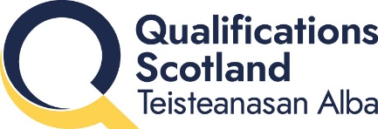

Research summary: Approaches and considerations for the assessment of writing: A review of literature from 2013–2026
Date: June 2026

Why did we do this research?
We wanted to study different examples of how writing is assessed and explore what impact generative artificial intelligence (AI) is having on how writing is assessed.

What are we trying to find out?
- What are different ways in which writing is assessed?
- Is writing assessment changing because of AI, and if so, how?
- What should we keep in mind moving forward?

How did we do the research?
We looked at literature sources about popular approaches to writing assessment over the past 13 years. These sources included academic articles published in journals, using the Taylor & Francis database, as well as internet articles and blogs published by lecturers and other education professionals.

What did we learn?
- Some issues that come up include the role of creativity in writing, marking that is fair but also efficient, and the application of writing skills in real world scenarios.
- Approaches to writing assessment must be compared by how well they can ensure fairness.
- There are examples in the literature that suggest AI is already changing writing assessment, including how assessments are designed, marked, and how educators can best check that submitted work reflects a learner’s true ability.

What will change because of the research?
This literature review will help prepare us for changes in how writing is assessed in the future.
Read the full report
You can read Approaches and considerations for the assessment of writing: A review of literature from 2013—2026 on our website.

